Final Program

There are four files (CISP430V4Final.exe, CISP430V4Final.cpp, CISP430V4Header.h, and CISP430V4Header.template) in CISP430V4Final.zip. You have to do debugging and commenting for this final program.

In the CISP430V4Final.cpp, CISP430V4Header.h, and CISP430V4Header.template files there are syntax and logic errors you have to make corrections on them. If you correct all the errors you can run the program to the CISP430V4Final.exe result. The following is the result of the program:
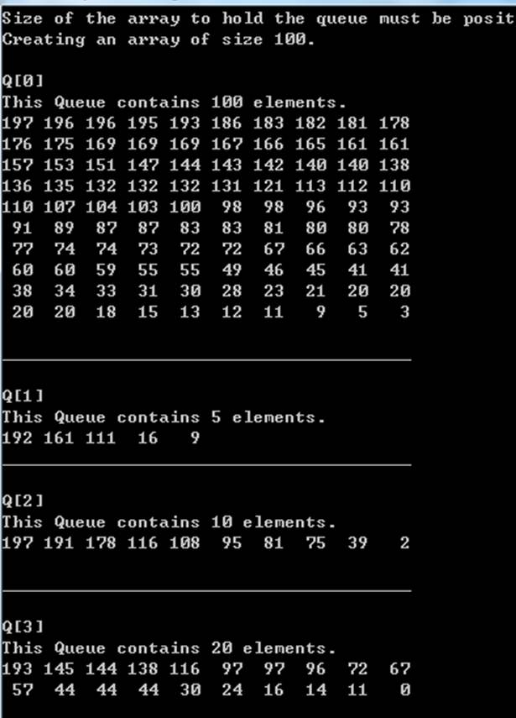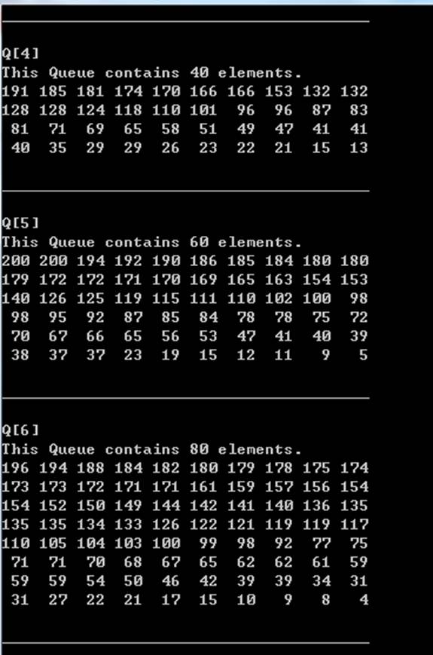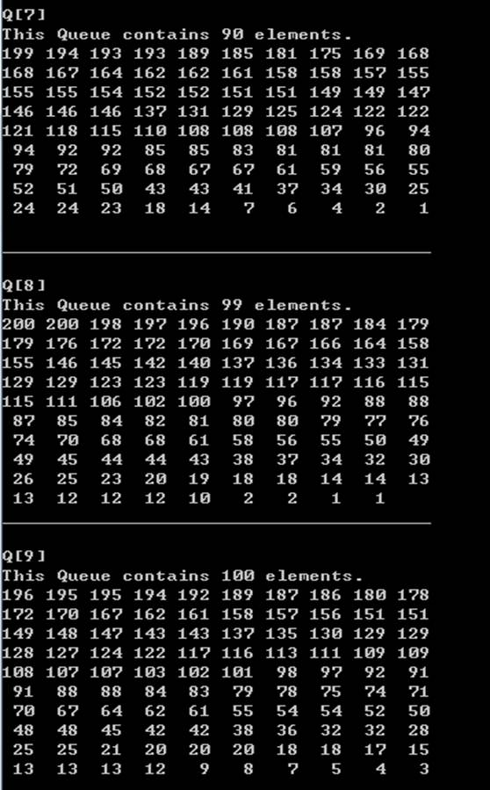

You need to understand the program first before start writing comments. There is something you need to do for commenting the program.
- You need to have your name, the class name, your student ID and purpose of the file at the beginning of each file (.cpp, .h and .template).
- You need to provide description (purpose) of each function before the declaration of the function (.cpp and .template).
- You need to provide description (purpose) of each section before the start of the section (.cpp and .template).
- You need to provide description (purpose) of each important line at the end of the lines (.cpp and .template).
- You need to provide description (purpose) for each statements and pre and post condition for functions(.h).
- You need to clear define the ending point of each section, function and program (.cpp, .h and .template).

When you are ready to submit, please zip all your files into a proper named (If your name is Charles Janewell, the file name for fall 2011 final program should be JanewellCFPCISP43011F.) zip file and submit the zip file to Final Program Examination dropbox in the D2L class website.

This final program is worth 400 points. The grading standard is as following:
- If your submitted program can generate a perfect result as CISP430V4Final.exe in Microsoft Visual Studio C++ 2010 environment you will earn 250 points.
- A perfect comment on all the required area, zip the files in a proper zip file name and submit it to the final program dropbox on time will earn 150 points.
- If any definition is not clear to or understand by the instructor the definition will earn little points.
- If the program does not submit to the proper folder, does not zip in a proper file named zip file or late the program will get little credit.
- If the program still has error(s) the program will earn little score.
- The grading is very subjective but the instructor will use the same standard across the board.

